© ICLT2023_2nd International Conference on Logistics and Transportation 2023
Title of the Paper with Capitalized Each Word and No Comma Allowed (DON’T USE CAPITAL LETTER)

Firstname LastName^{1*}, FirstName LastName², FirstName LastName¹, FirstName LastName³

¹ Department or Institute or Faculty or Center must be given, Universiti Teknologi MARA, 40450 Shah Alam, Selangor, MALAYSIA.
² Centre for Instruction, Technology and Management, University of Extensive Research, Penang, MALAYSIA.
³ Department or Institue or Faculty or Center must be given, University of Big River, Nakorn Nayok, THAILAND.

Email All Authors:

*Corresponding Author (Tel: +60122290000, CorrepsondingAuthorEmail@UniversityeMail.Edu)

Abstract
This abstract should less than 200 words. Be precise and concise, the abstract should summarize your study and findings. Do not change any format. After done, please save as “docx” file. This template explains how to format and write your manuscript. The paper must not have any kind of break (section break, page break). The manuscript should be headed by a concise title. Please include the full name(s) of the author(s) and complete mailing address. In case of multiple authorship, please indicate the main author to whom all correspondence concerning the paper should be directed. The manuscript should clearly indicate the Corresponding Author. Ensure that phone number(s) (with country and area code) are provided in addition to the e-mail address and the complete postal address. Contact details must be kept up to date by the corresponding author.

Keywords: At least five keywords; Separated by a semi-colon.

1. Introduction
Do not change any format of this file. Section break and page break are not allowed. Manuscripts submitted to ICLT 2023 must be original work that has not been published or under consideration for publication elsewhere. The manuscript must be written in good English (American or British usage is accepted, but not a mixture of these) and should be no more than 10 pages in length inclusive of tables, figures and illustrations. All submissions will be single blind peer reviewed. The abstract and conclusions section must highlight what is new and/or novel in the paper. Type of manuscript is Full Articles, containing original research work. Headings example: Introduction, Literature Review, Methods, Results and Discussion, Conclusions, Acknowledgements, References. Therefore, review paper is not accepted.
Full or Regular article is a full-length original empirical investigation, consisting of introduction, methods, results, and discussion. Original research work should present new and significant findings that contribute to the advancement of the research area. Analysis and Discussion must be supported with relevant references.
Introduction should state the objectives of the work and provide an adequate background, avoiding a detailed literature survey or a summary of the results.

Information
Science and Technology disciplines based paper must have less than 5000 words including everything, Single column with a maximum of 10 pages length. While, Social Science based paper must must have more than 6000 to 7000 words including everything, Single column with a maximum of 18 pages length.
Click “Body” for all paragraph writings (Thiandee et al., 2019), see Figure 1.
All Figure images must be sharp of high quality, with clear big texts.

Instruction
Other instructions are given below.
- All Tables are in a form of cells (texts), not box or border or image, please put all the units.
- Images must be of high quality (preferably 300+ dpi), with big font readable texts/symbols and units.
- ICLT 2023 publishes only new materials (except that you create to put in your thesis/dissertation and a note is needed).
- Plagiarism checks: Each and all manuscripts, Turn-It-In and/or other engines are used for similarity checks. ICLT 2023 allows a maximum of 20% Turn-It-In score, for 5 consecutive words checking. Images and other materials are randomly checks.
- We accept APA style reference format and citation writing only.
  - The paper uses only the last name of authors. Citation writing, this paper uses “et al.” for all places for citing a paper with 3 authors and more, followed by year.
  - Citation writing follows APA format style
  - All references must follow APA style format
  - All references items must be cited/mentioned in your writing.
  - Delete all non-mentioned reference items.
  - Citation check: All cited/mentioned others' works must be found in References list.
- Make sure statistic data/interpretation of the result. You have to check your and conclude your hypotheses (Accepted or Rejected).
- Result: Please show only 2-3 decimals. Is it meaningful to show many decimals? (Your results have how many significant figures?)
- In this paper, Equations, Table, and Figure are sequentially numbered. Table 1, Table 2, Table 3, ... Table 10. Figure 1, Figure 2, Figure 3, ... Figure 10. For Equation, please put (1), (2), … at the end on the right-side of the Equation.

  - All Tables and Figures must be mentioned/explained in writing.
  - Tables and Figures are mentioned by number (not accepted Table below, Figure above)
  - Delete all not mentioned/explained Tables/Figures.
- Please explain all the symbols, subscripts, and superscripts used in the paper.
- Please give the full terms of abbreviations.
- All the graphs contain titles of x and y-axis, with units.
- Keywords: Please give at least 5 keywords.
- The corresponding name and email are given. Email must contain the name.
We will return the manuscript back to you if you do not follow this guideline.

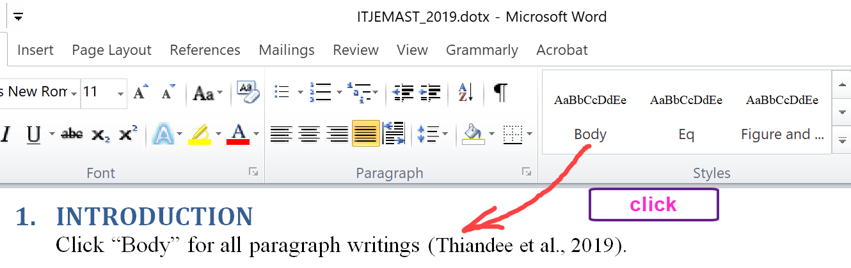
Figure 1: Click Figure and from the style box in Word, it should show font size 12.

2. Literature Review
Recent literature should be reviewed and cited (Anantakarn, et al, 2019). All the writing should be concise and precise. No need to put the general knowledge. We will check all papers for plagiarism using software such as TurnItIn® or iTthenticate® or Grammarly® or others. The publication time may vary, depending on the quality of each paper that corrections are required.
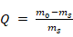 (2),
where Equation is considered as a part of the sentence. Please make sure that all symbols are explained.
2.1 Click Heading 2 from the Styles Format for the Sub-topic
See Figure 2 for Heading 2, the format will be set automatically.
2.1.2 Heading 3 (Click Heading 3 from the Styles Format for the Sub-subtopic)
Click Heading 3 as shown in Figure 2.

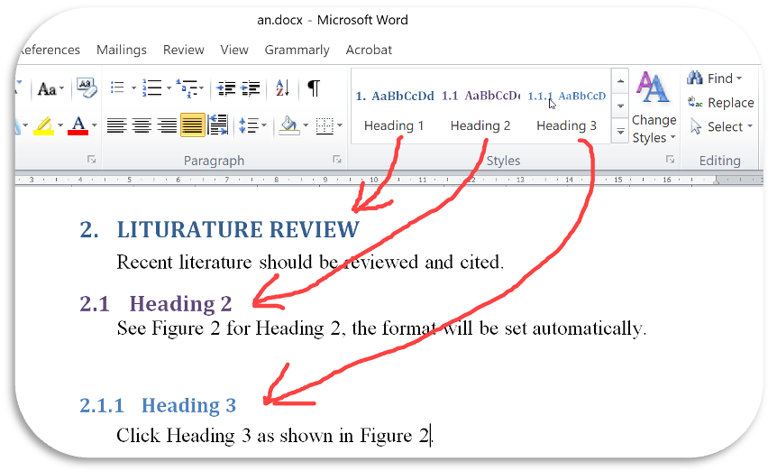
Figure 2: Just “click” from Styles in the Home tab.
3. Method
3.1 Figure and Table
Figure and Table is not a topic in your paper. We put it here only to explain the detail. Author should select “In line with text” for Figure and Table (Click Figure or whole Table that you want to set a Format ➔ Format tab ➔ Wrap Text ➔ In line with text). Figure and Table can be automatic set center by click “Figure and Table” from Styles, see Figure 3.

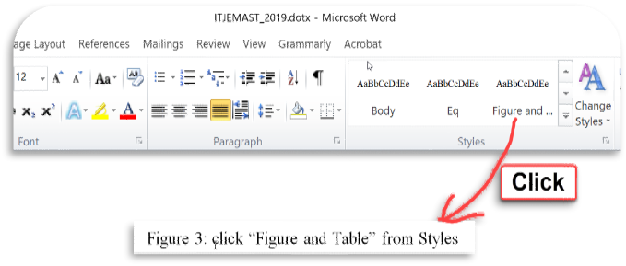
Figure 3: click “Figure and Table” from Styles
4. Results and Discussion
Data result in Table 1 uses “Text Size 10” (click Table2 in the Styles format). Please explain all symbols in Equations, Figures, and Table.

Table 1: Analyzed result (click Figure and Table in the Styles format, get font size 12).
Please put units.
Item | Mean | SD | p-value (Click Table2)
1 | 0.61 | 0.16 | 0.14
2 | 0.16 | 0.10 | 0.03
3 | 0.40 | 0.08 | 0.48

5. Conclusion
Be concise and precise to summary your study. Important findings from your study are reported and emphasized here. The conclusion should not longer than 300 words.

Acknowledgement
Any individuals and entities who have contributed to the research should be acknowledged appropriately. Eg., The authors appreciate the financial supports from the Double Twin Foundation, under the contract number FG2021-987.

References

Thiandee, P., Witchayangkoon, B., Sirimontree, S., Lertworawanich. (2019). An Experiment on Measurement of Pavement Roughness via Android-Based smartphones. International Transaction Journal of Engineering, Management, & Applied Sciences & Technologies. 10(9), 10A09G, 1-9.

Anantakarn, K., Sornchomkaew, P., Phothong, T. (2019). Improve Quality of Global DEM for Topographic Mapping: Case Study of Petchaburi Province, Thailand. International Transaction Journal of Engineering, Management, & Applied Sciences & Technologies. 10(9), 10A09H, 1-9.
Nayak, P. (2008). Vibration Analysis of Woven Fiber Glass / Epoxy Composite Plates Vibration Analysis of Woven Fiber Glass / Epoxy Composite Plates. Master Thesis, Technology in Civil Engineering, National Institute of Technology, Rourkela.
Zahid, R., Masjuki, H., Varman, M., Mufti, R., Kalam, M. A., Gulzar, M., & Yunus, R. (2015). Comparison of tribological performance of zinc dialkyldithiophosphate (ZDDP) in poly-alpha-olefin (PAO) and palm oil-based trimethylopropane (TMP) ester. In Proceedings of Malaysian International Tribology Conference, pp. 201-202.
Stachowiak, G., & Batchelor, A. W. (2013). Engineering Tribology. Butterworth-Heinemann.
Note: References are listed in alphabetical order by the first author’s last name. Only references cited within the text should be included. If a Digital Object Identifier (DOI) is listed on a print or electronic source, it is required to include the DOI in the reference list. Use Crossref to find a DOI using author and title information. When formatting your references, please follow the APA-reference style (refer to the examples). Ensure that the references are strictly in the APA style, failing which your article will not be accepted for publication. You may refer to the Publication Manual of the American Psychological Association (https://apastyle.apa.org/) for further details. Examples of reference style for various types of publication sources are given below:
